**SCREENSHOOT**

# PEMROGRAMAN WEB DAN MOBILE 1



|  |  |
| --- | --- |
| **NAMA :** | **A.IRWIN PUTRA PANGESTI** |
| **NIM :** | **223020503162** |
| **KELAS :** | **1 (AP 1)** |
| **MODUL :** | **III**  (**PHP MySQL Database)** |

**JURUSAN TEKNIK INFORMATIKA**

**FAKULTAS TEKNIK**

# UNIVERSITAS PALANGKA RAYA

**2024**

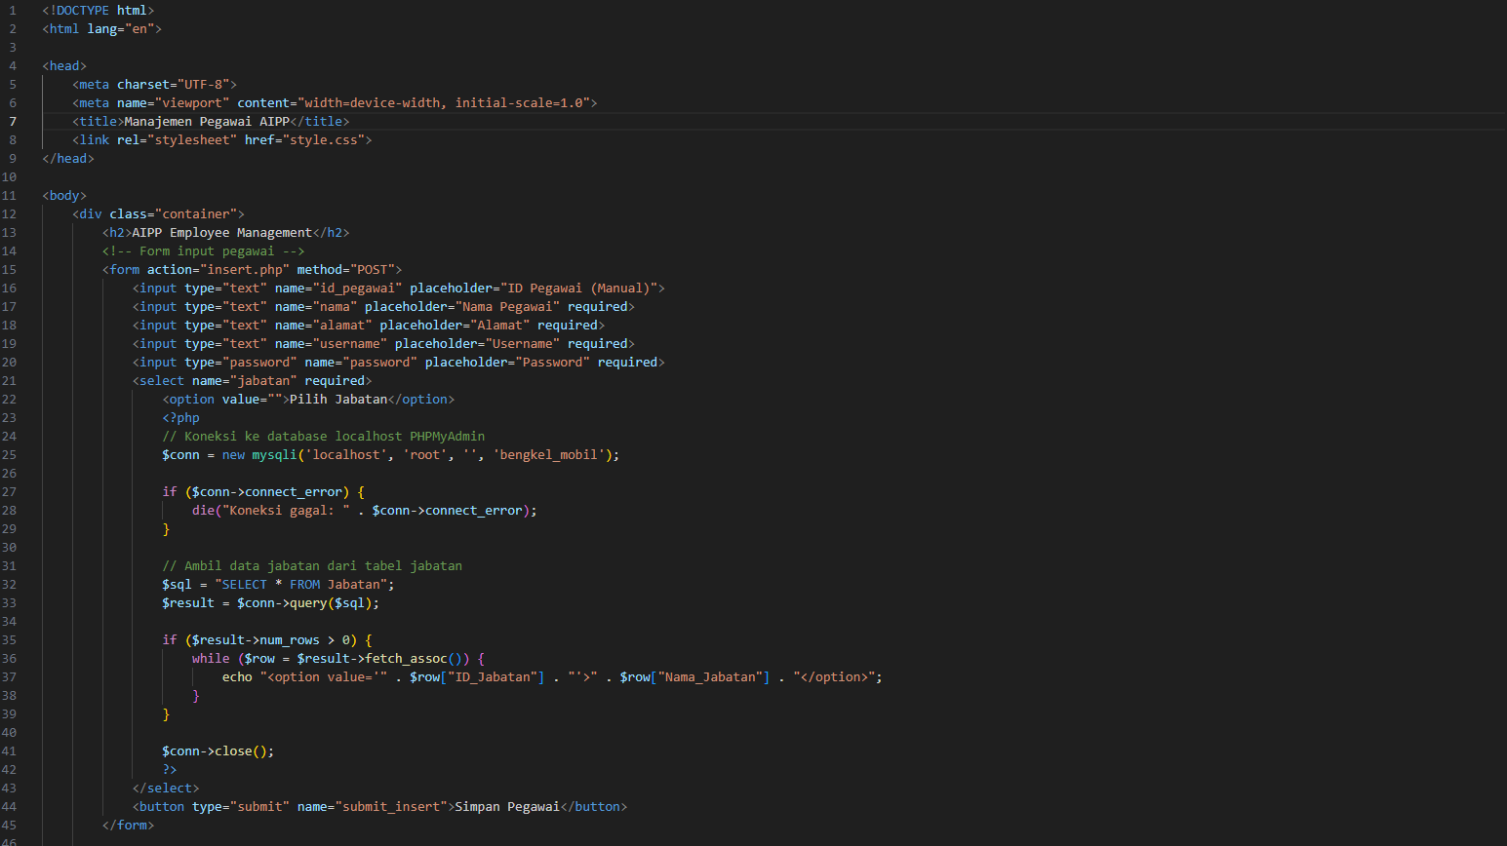**INDEX.PHP:**

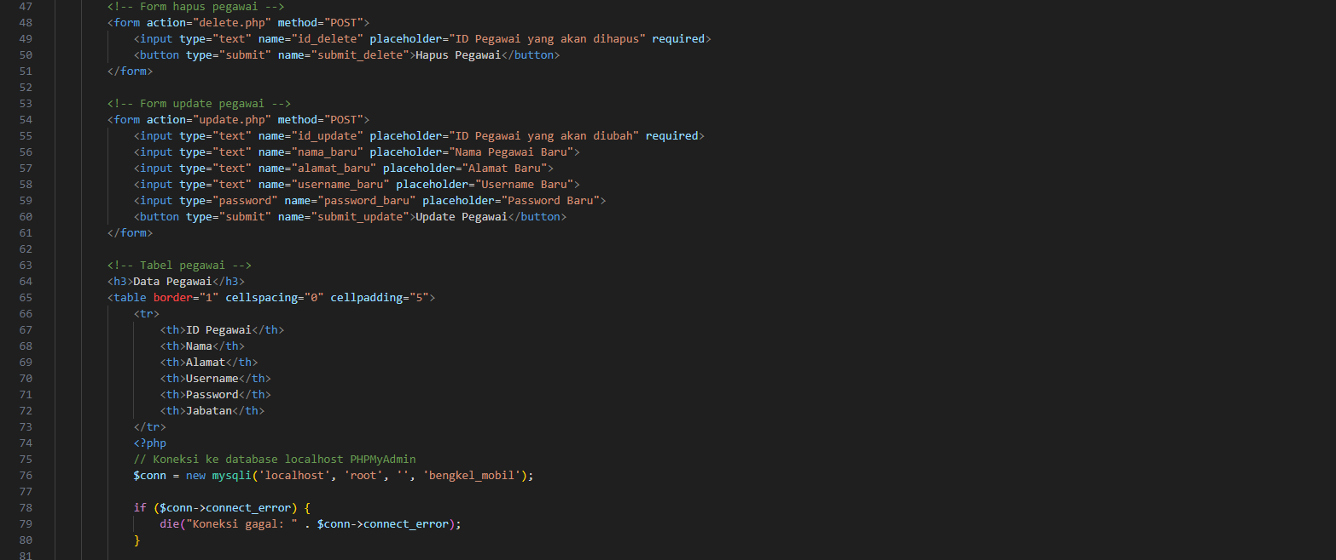

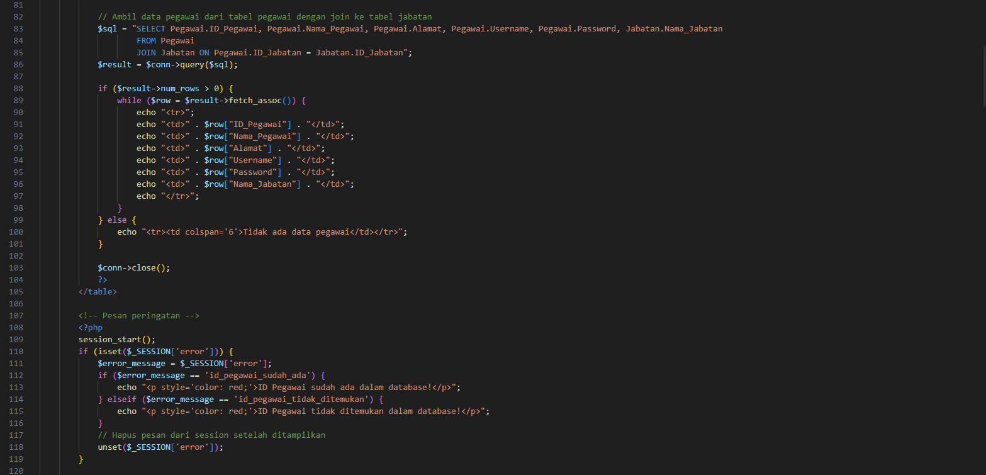

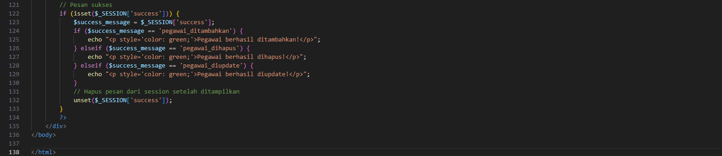

**STYLE.CSS:**

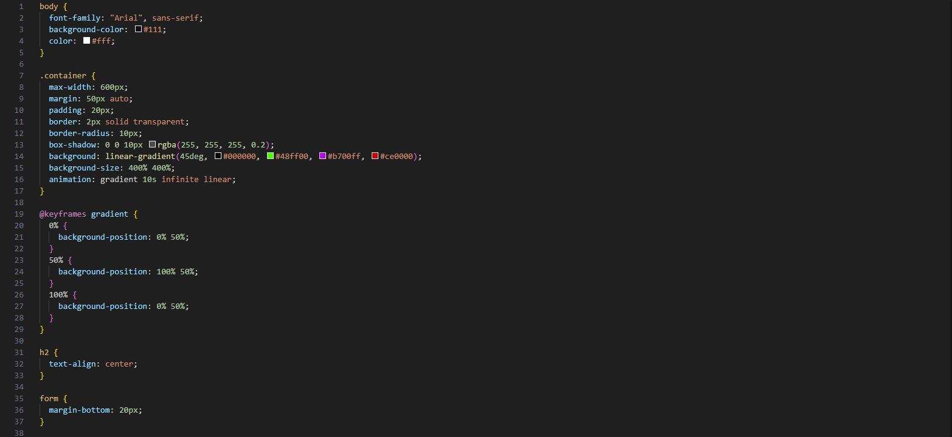

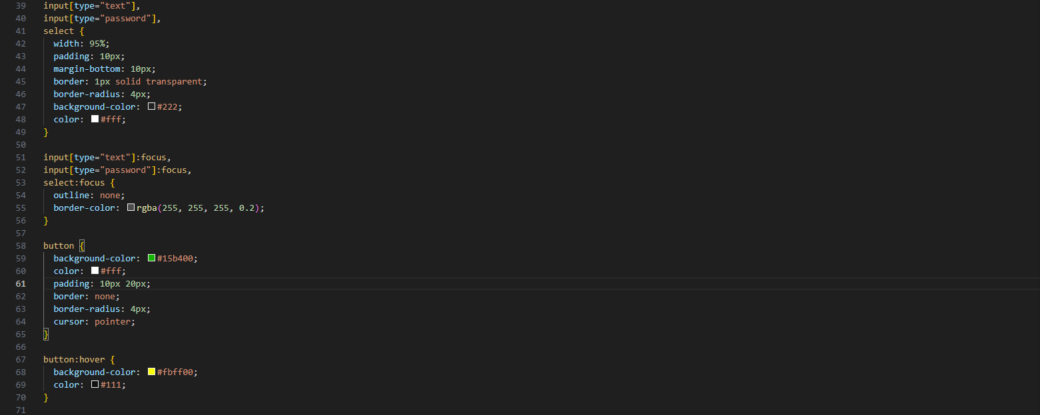

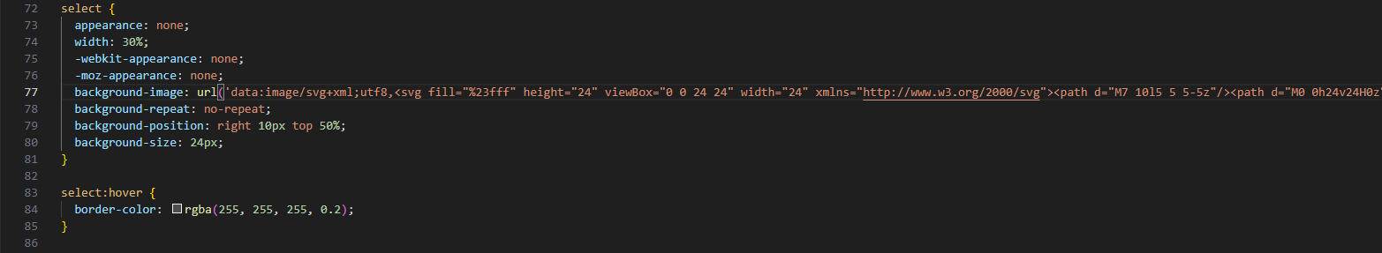

**INSERT.PHP:**

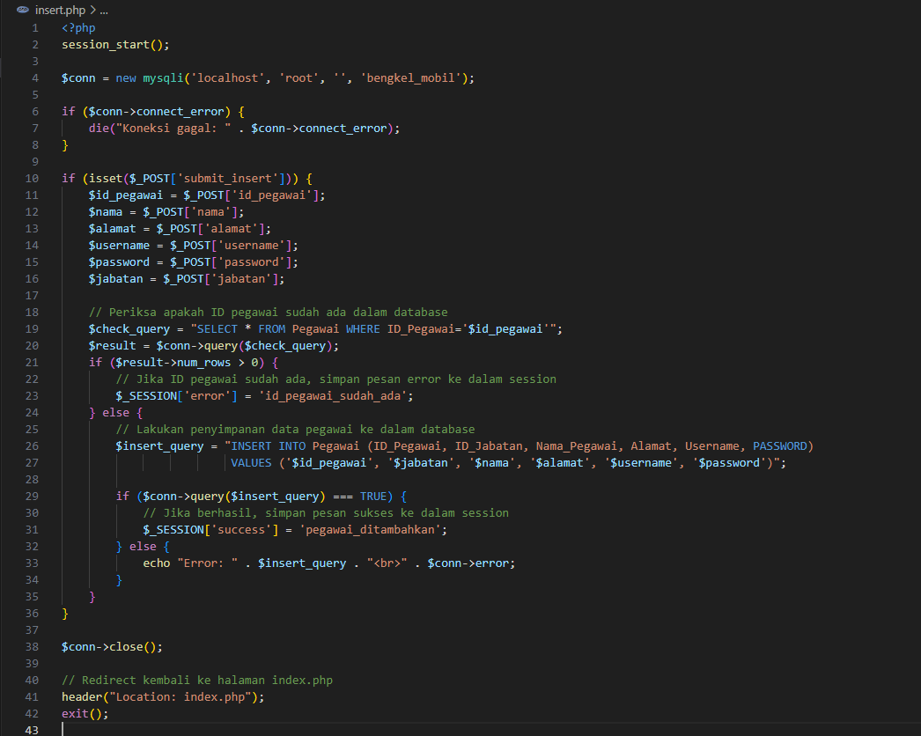

**DELETE.PHP:**

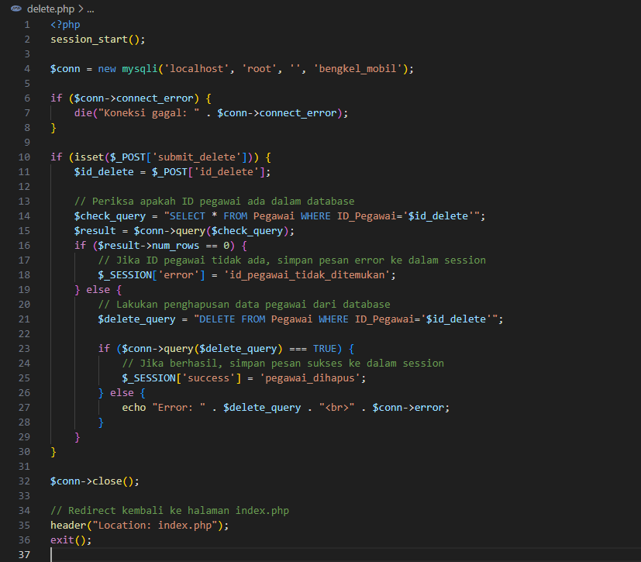

**UPDATE.PHP:**

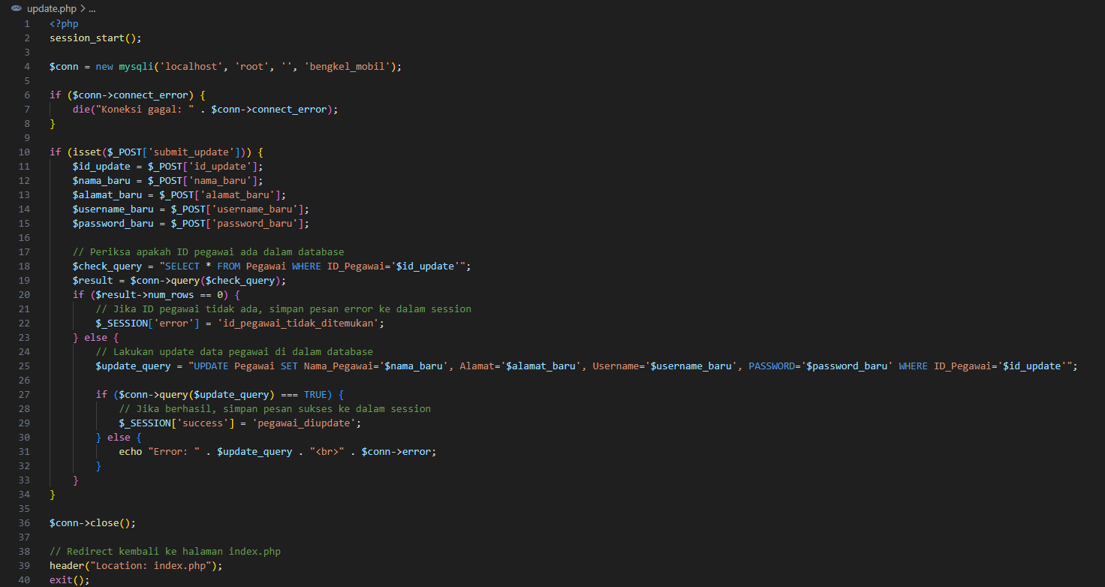

**OUTPUT:**

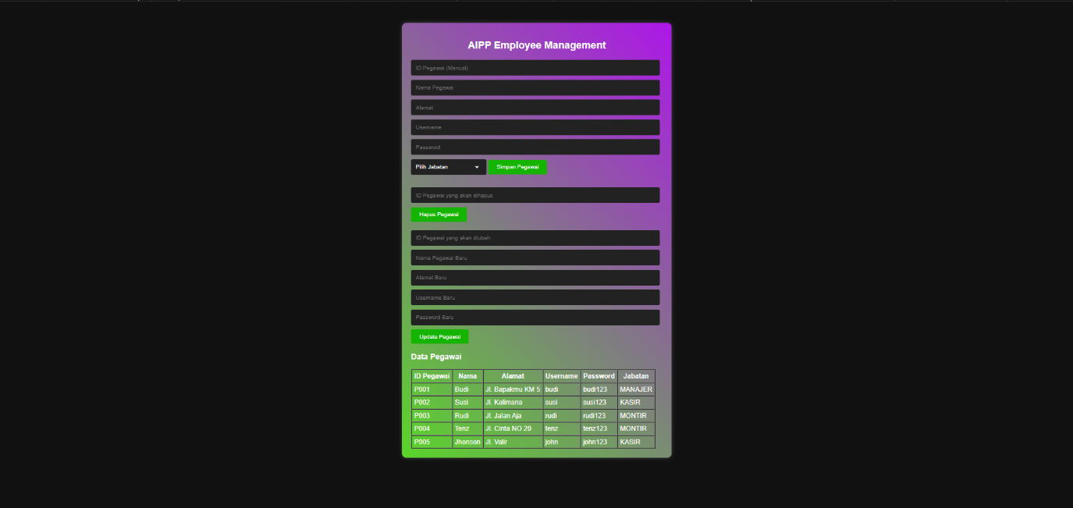

**RELASI TABEL PADA DATABASE:**

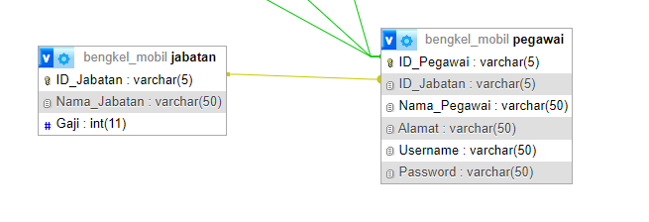



**DATABASE:**

1. 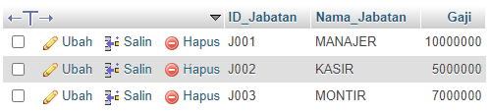**Tabel Jabatan**
2. 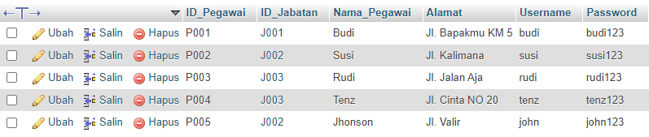**Tabel Pegawai**